- Create a new process by invoking the appropriate system call. Get the process identifier of the currently running process and its respective parent using system calls and display the same using a C program.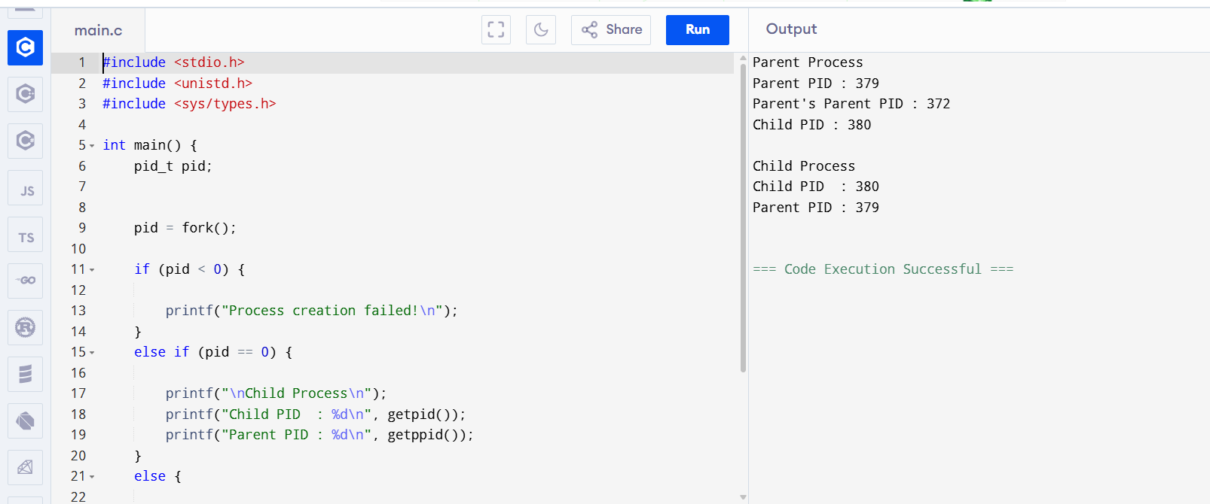 2.Identify the system calls to copy the content of one file to another and illustrate the same using a C program.
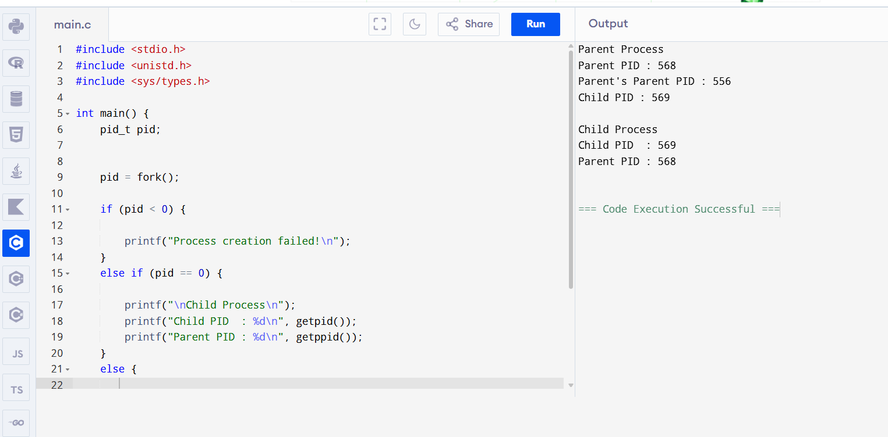 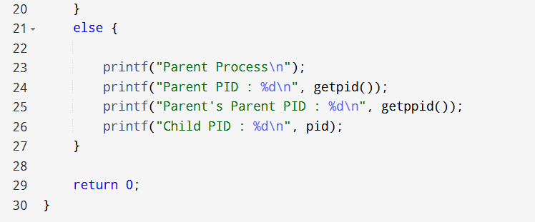3.Design a CPU scheduling program with C using First Come First Served technique with the following considerations. a. All processes are activated at time 0. b. Assume that no process waits on I/O devices 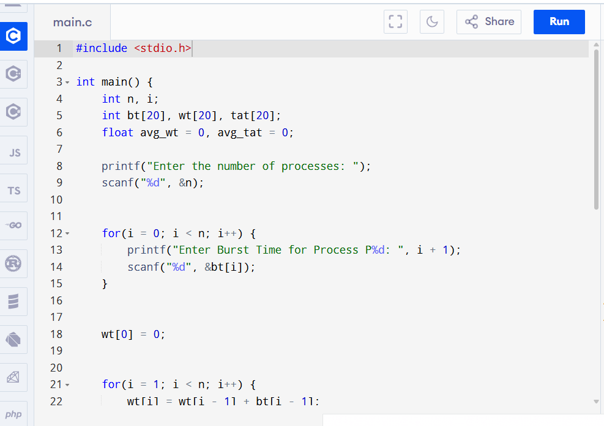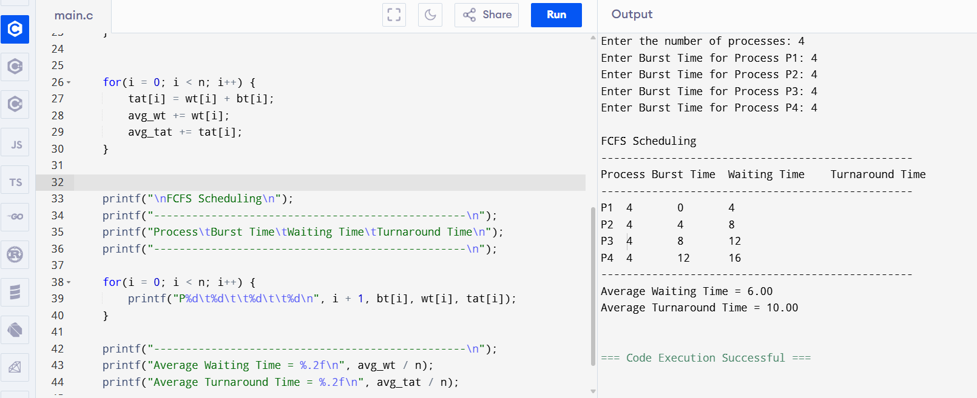

4.Construct a scheduling program with C that selects the waiting process with the smallest execution time to execute next 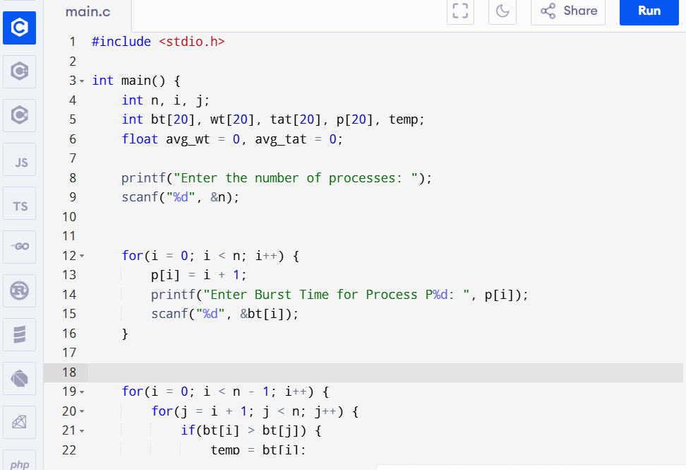

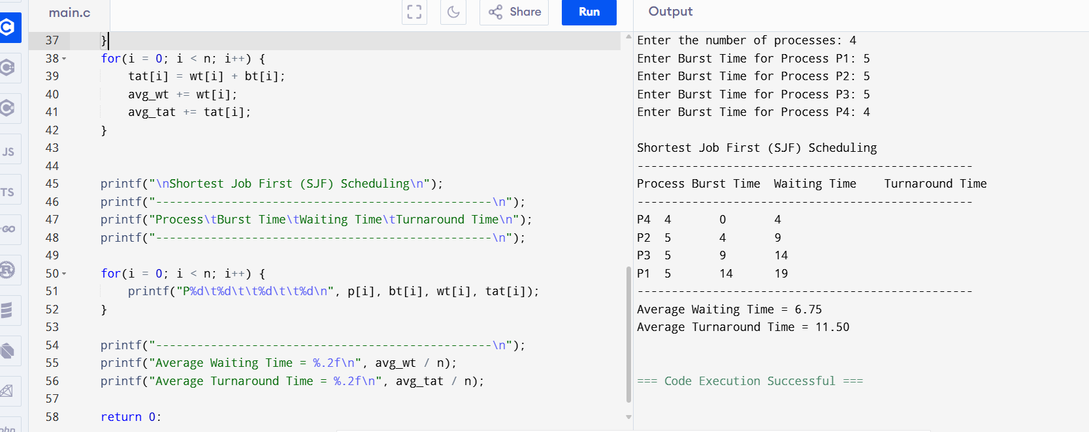

5.Construct a scheduling program with C that selects the waiting process with the highest priority to execute next.
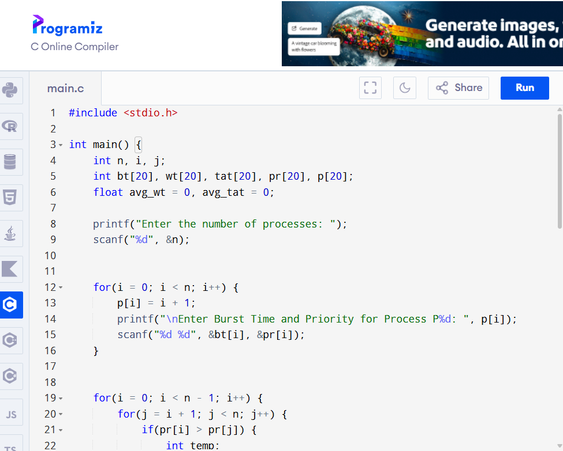

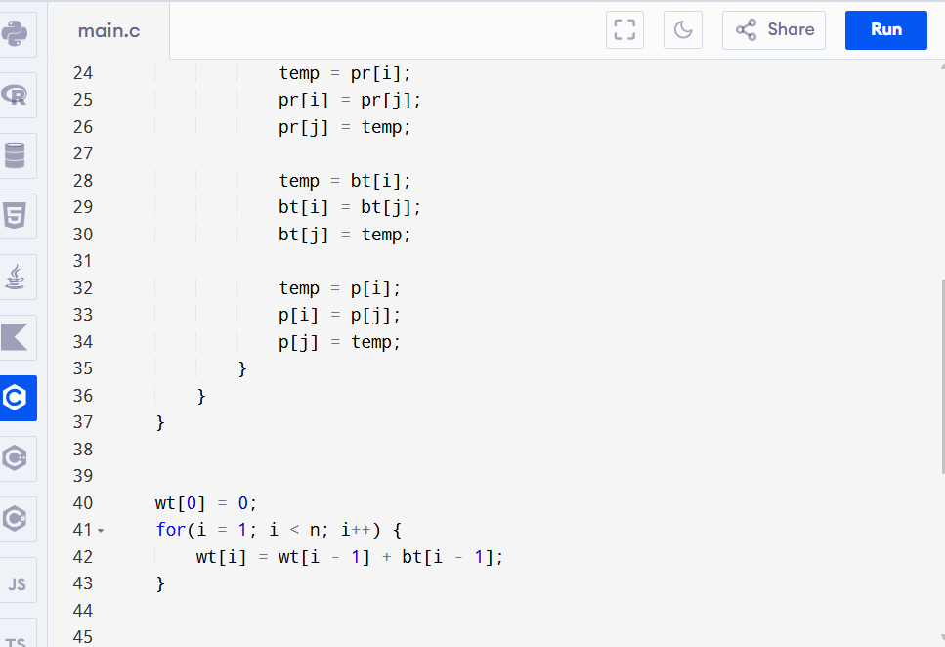
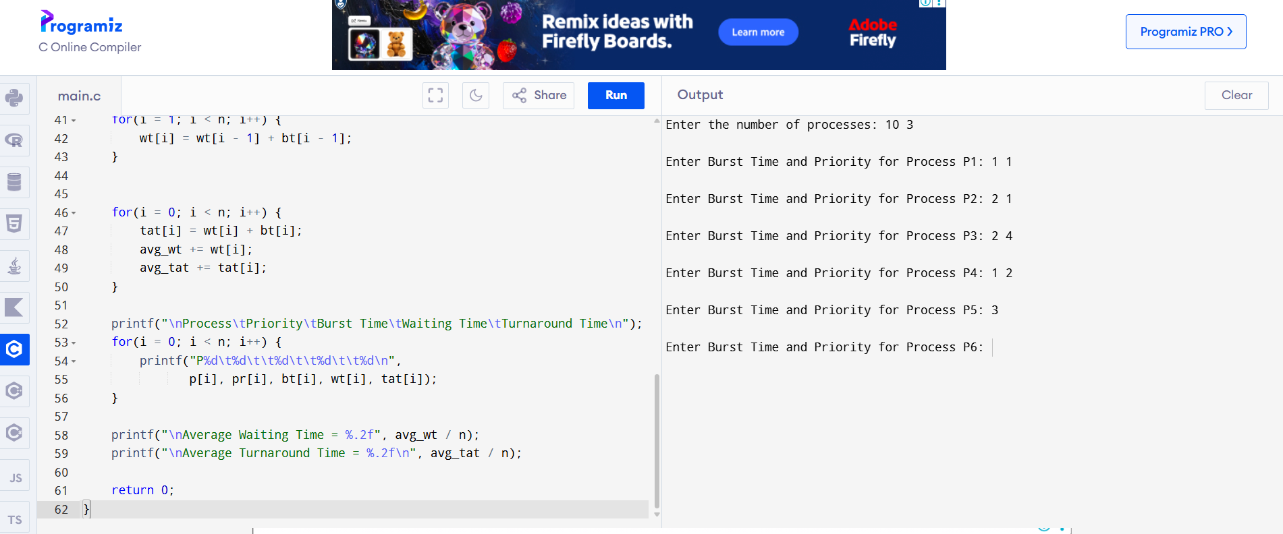

6.Construct a C program to implement preemptive priority scheduling algorithm
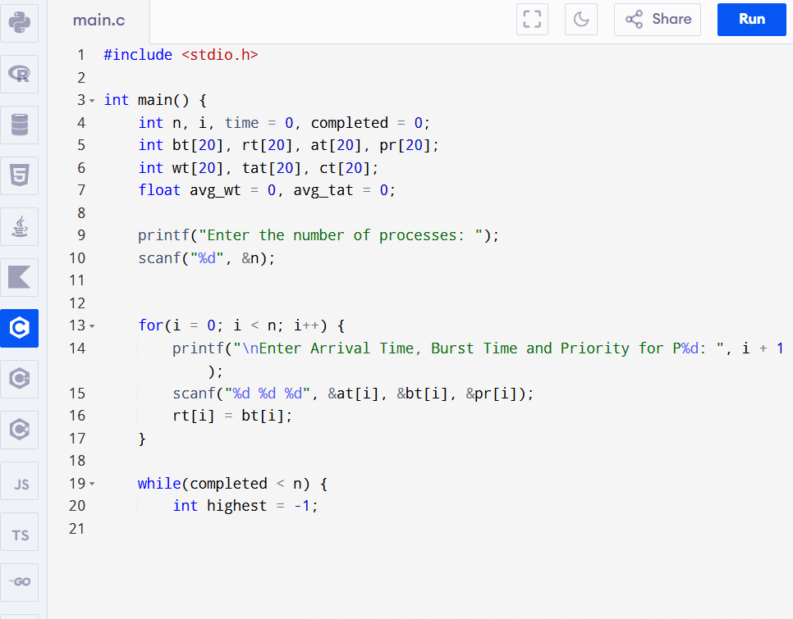
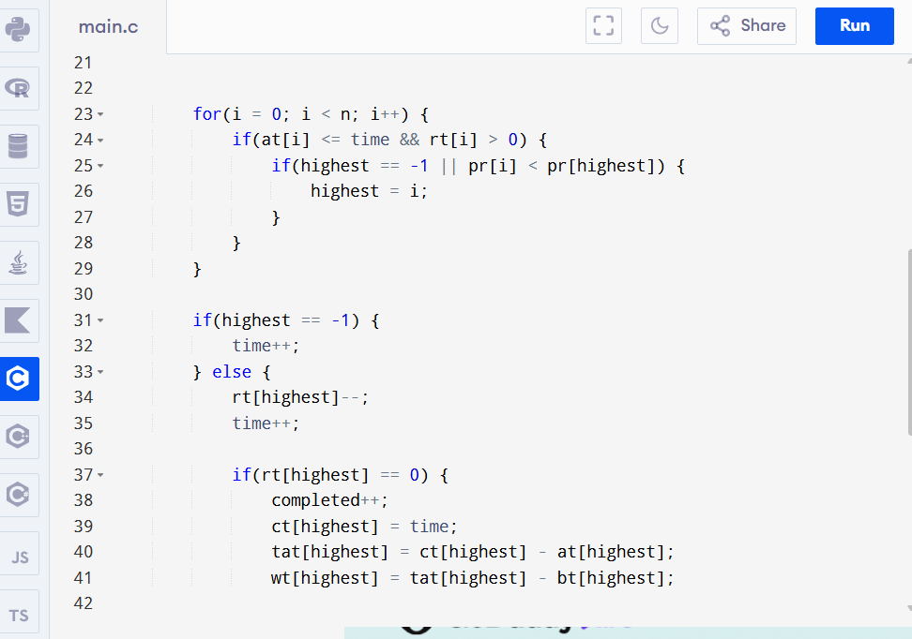

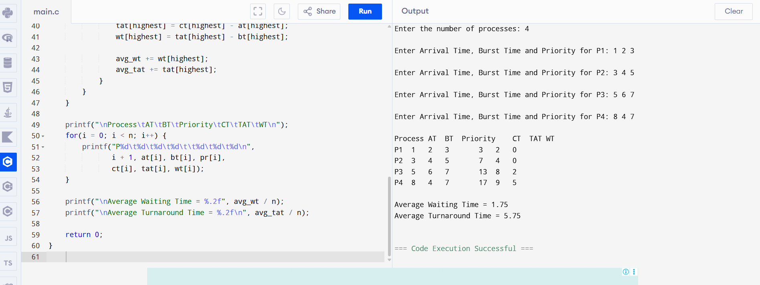

7. Construct a C program to implement a non-preemptive SJF algorithm.
#include <stdio.h>

int main() {
int n, i, j;
int bt[20], at[20], wt[20], tat[20], ct[20];
int completed[20] = {0};
int time = 0, done = 0;
float avg_wt = 0, avg_tat = 0;

printf("Enter the number of processes: ");
scanf("%d", &n);

// Input Arrival Time and Burst Time
for(i = 0; i < n; i++) {
printf("Enter Arrival Time and Burst Time for P%d: ", i + 1);
scanf("%d %d", &at[i], &bt[i]);
}

while(done < n) {
int shortest = -1;

// Find the shortest job among arrived processes
for(i = 0; i < n; i++) {
if(at[i] <= time && completed[i] == 0) {
if(shortest == -1 || bt[i] < bt[shortest]) {
shortest = i;
}
}
}

if(shortest == -1) {
time++; // CPU is idle
} else {
time += bt[shortest];
ct[shortest] = time;
tat[shortest] = ct[shortest] - at[shortest];
wt[shortest] = tat[shortest] - bt[shortest];

completed[shortest] = 1;
done++;

avg_wt += wt[shortest];
avg_tat += tat[shortest];
}
}

printf("\nProcess\tAT\tBT\tCT\tTAT\tWT\n");
for(i = 0; i < n; i++) {
printf("P%d\t%d\t%d\t%d\t%d\t%d\n",
i + 1, at[i], bt[i], ct[i], tat[i], wt[i]);
}

printf("\nAverage Waiting Time = %.2f", avg_wt / n);
printf("\nAverage Turnaround Time = %.2f\n", avg_tat / n);

return 0;
}

Output:
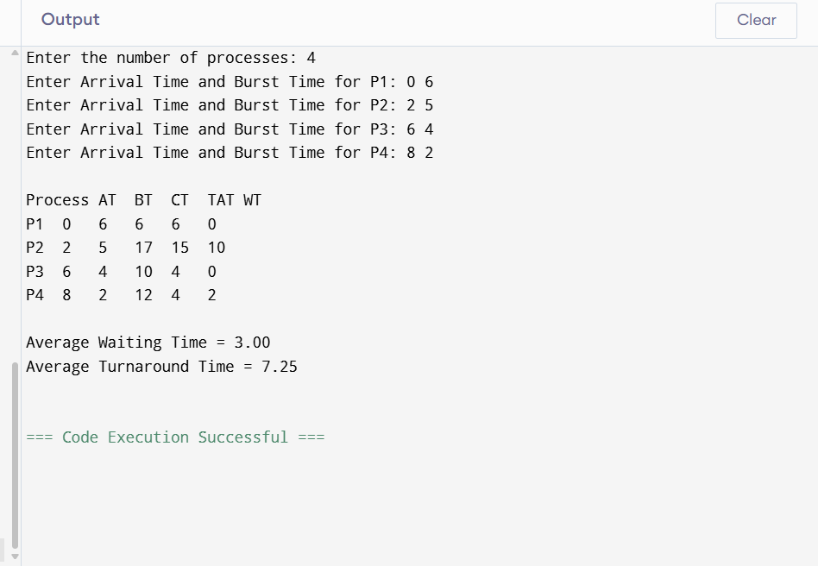

8. Construct a C program to simulate Round Robin scheduling algorithm with C.

#include <stdio.h>

int main() {
int n, i, tq;
int bt[20], rt[20], wt[20], tat[20];
int time = 0, completed = 0;

printf("Enter the number of processes: ");
scanf("%d", &n);

// Input Burst Time
for(i = 0; i < n; i++) {
printf("Enter Burst Time for P%d: ", i + 1);
scanf("%d", &bt[i]);
rt[i] = bt[i]; // Remaining Time
}

printf("Enter Time Quantum: ");
scanf("%d", &tq);

while(completed < n) {
int done = 1;

for(i = 0; i < n; i++) {
if(rt[i] > 0) {
done = 0;

if(rt[i] > tq) {
time += tq;
rt[i] -= tq;
} else {
time += rt[i];
wt[i] = time - bt[i];
rt[i] = 0;
completed++;
}
}
}

if(done)
break;
}

// Calculate Turnaround Time
float avg_wt = 0, avg_tat = 0;

for(i = 0; i < n; i++) {
tat[i] = bt[i] + wt[i];
avg_wt += wt[i];
avg_tat += tat[i];
}

printf("\nProcess\tBurst Time\tWaiting Time\tTurnaround Time\n");
for(i = 0; i < n; i++) {
printf("P%d\t%d\t\t%d\t\t%d\n",
i + 1, bt[i], wt[i], tat[i]);
}

printf("\nAverage Waiting Time = %.2f", avg_wt / n);
printf("\nAverage Turnaround Time = %.2f\n", avg_tat / n);

return 0;
}
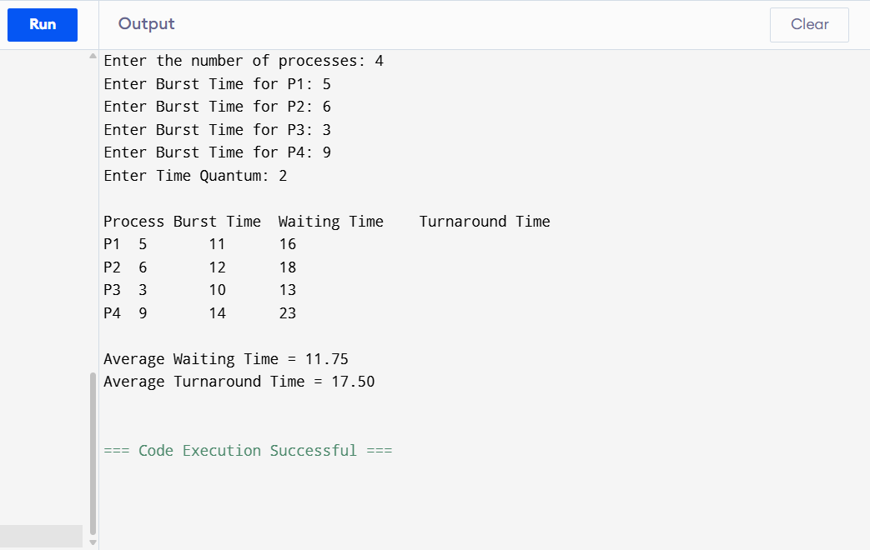
9. Illustrate the concept of inter-process communication using shared memory with a C program.

#include <stdio.h>
#include <stdlib.h>
#include <string.h>
#include <unistd.h>
#include <sys/ipc.h>
#include <sys/shm.h>
#include <sys/types.h>
#include <sys/wait.h>

int main() {
key_t key = 1234;
int shmid;
char *shm_ptr;

// Create shared memory
shmid = shmget(key, 1024, 0666 | IPC_CREAT);
if (shmid < 0) {
perror("shmget");
exit(1);
}

// Attach shared memory
shm_ptr = (char *)shmat(shmid, NULL, 0);
if (shm_ptr == (char *)-1) {
perror("shmat");
exit(1);
}

if (fork() == 0) {
// Child process
sleep(1); // Wait for parent to write
printf("Child Process Read: %s\n", shm_ptr);

// Detach shared memory
shmdt(shm_ptr);
} else {
// Parent process
strcpy(shm_ptr, "Hello from Parent using Shared Memory!");

printf("Parent Process Wrote: %s\n", shm_ptr);

wait(NULL);

// Detach and remove shared memory
shmdt(shm_ptr);
shmctl(shmid, IPC_RMID, NULL);
}

return 0;
}
Output:
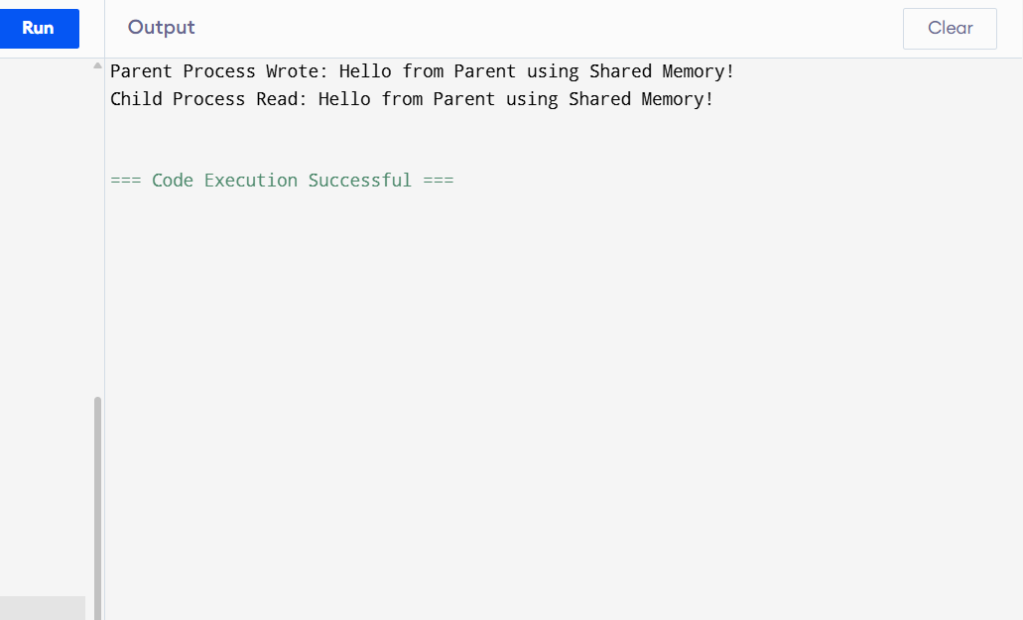

10. Illustrate the concept of inter-process communication using message queue with a C program.

#include <stdio.h>
#include <stdlib.h>
#include <string.h>
#include <unistd.h>
#include <sys/ipc.h>
#include <sys/msg.h>
#include <sys/types.h>
#include <sys/wait.h>

// Structure for the message
struct message {
long msg_type;
char msg_text[100];
};

int main() {
key_t key = 1234;
int msgid;
struct message msg;

// Create message queue
msgid = msgget(key, 0666 | IPC_CREAT);
if (msgid == -1) {
perror("msgget");
exit(1);
}

if (fork() == 0) {
// Child process: Receive message
msgrcv(msgid, &msg, sizeof(msg.msg_text), 1, 0);
printf("Child Process Received: %s\n", msg.msg_text);
} else {
// Parent process: Send message
msg.msg_type = 1;
strcpy(msg.msg_text, "Hello from Parent using Message Queue!");

msgsnd(msgid, &msg, sizeof(msg.msg_text), 0);
printf("Parent Process Sent: %s\n", msg.msg_text);

wait(NULL);

// Remove the message queue
msgctl(msgid, IPC_RMID, NULL);
}

return 0;
}

Output:
